

Event Report
on
SENSE HACK 2025
Theme: Advancing Technologies for the Betterment of Humanity
A national-level 36-hour hackathon
(from 8.00AM, on 6th Dec. to 8.00PM, on 7th Dec., 2025)
Organized by
IEEE SB VIT and IEEE ComSoc SB VIT
in collaboration with
Office of Students’ Welfare,
School of Electronics Engineering
Student Activity Council, IEEE Madras Section

Venue: Anna Auditorium, VIT, Vellore.

SENSE HACK 2025
Theme: Advancing Technologies for the Betterment of Humanity
SENSE HACK 2025, a national-level 36-hour hackathon organized by IEEE SB VIT and IEEE ComSoc SB VIT in collaboration with the Office of Students’ Welfare, School of Electronics Engineering and the IEEE Madras Section, was held from 8.00AM, on 6th Dec. to 8.00PM, on 7th Dec., 2025 at the Anna Auditorium, VIT, Vellore.
Participants from various institutions across the country have been invited to take part in this event. The hackathon aims to foster innovation and problem-solving among undergraduate students, offering expert mentorship and a platform to develop impactful prototype solutions. To further encourage our UG freshers, the Best Freshers’ Team Award has been introduced exclusively for first-year students.
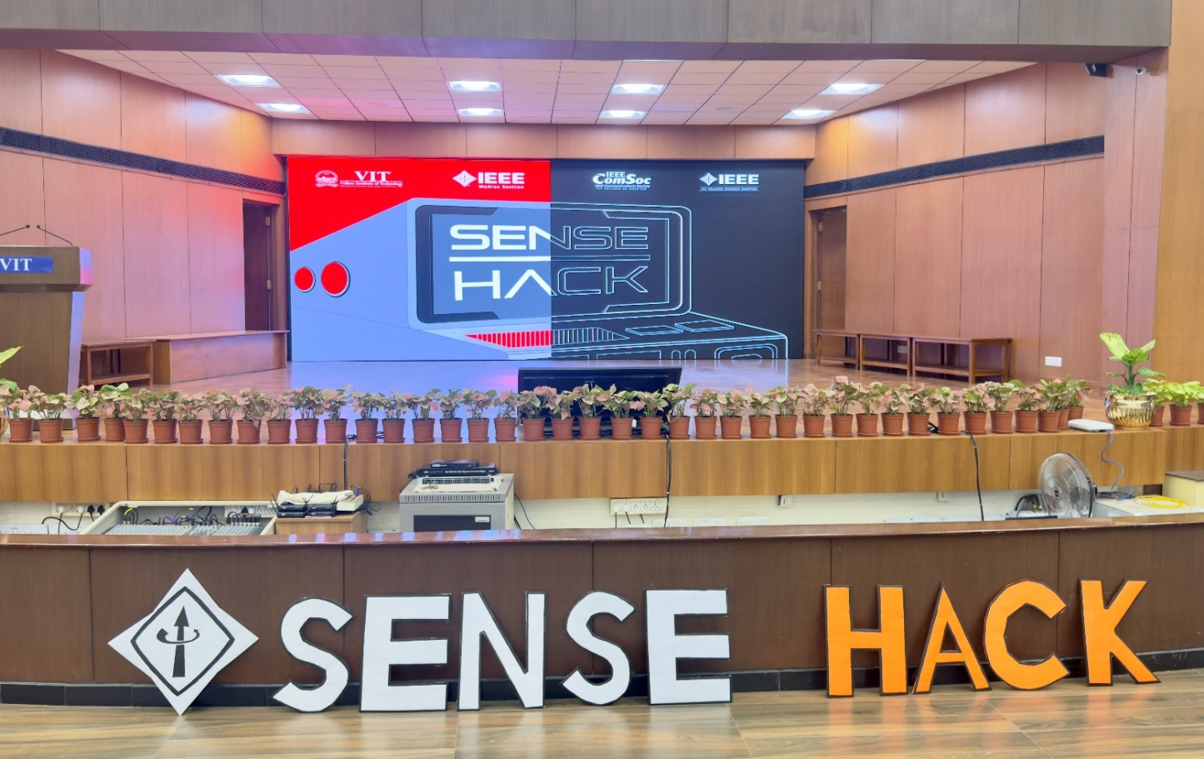
The hackathon dives into seven different tracks, providing participants with a wide range of domains to explore and contribute innovative solutions.
- Smart Healthcare & Well-being
- Smart Cities & Infrastructure
- Digital Education & Skill Development
- Fintech & Digital Inclusion
- Sustainable Environment & Green Tech.
- Cybersecurity & Digital Trust
- Open Innovation
To ensure effective and insightful evaluation, industry mentors have been invited to judge the teams. Most of these mentors are distinguished VIT alumni, adding value through their expertise and industry experience. The details of the mentors are provided below.
- Dr. Malay Kumar Nema – Scientist F, CAIR, DRDO, Bangalore
- Rishiraj Singh Chhabra – SDE-2 Full Stack, Licious
- Varun Sudhir – Analyst, Bain Capability Network
- Adi Manish Gulalkari – Data Science Specialist at GE Aerospace
- Sriram S – Junior Developer at FIS
- Sai Sahith Goud Bonugala – Product Engineer at Multipli finance
- Sriharsha Bommana – AI Researcher, Lossfunk
- Balakumaran M – Senior Technical Lead, EY
With the industry experts, the judging panel also include VIT professors from various domains. The details of the professors are provided below:
- Dr. S. Rajalakshmi, Assistant Professor Sr. Grade 1, SENSE
- Dr. Suraj Prakash Sahoo, Assistant Professor Sr. Grade 1, SENSE
- Dr. G. Sumathi, Assistant Professor Sr. Grade 1, SENSE
- Dr. Rajesh R, Associate Professor Grade 2, SENSE
- Dr. Gerardine Immaculate Mary, Professor Grade 1, SENSE
- Dr. R. Sivacoumar, Associate Professor Sr., SENSE
- Dr. Pradheep T, Associate Professor Grade 2, SENSE
- Dr. Suresh Kumar T R, Associate Professor Sr., SENSE
- Dr. Boopalan G, Associate Professor Grade 1, SENSE
- Dr. Sharmila N, Associate Professor Grade 2, SENSE
- Dr. Kumaravel S, Professor Grade 1, SENSE

HACK STATISTICS
Tracks | Submitted |  | Shortlisted
Tracks | Internal | External | Internal | External
Smart Healthcare & Well-being | 74 | 11 | 22 | 11
Smart Cities & Infrastructure | 29 | 8 | 21 | 8
Digital Education & Skill Development | 14 | 7 | 6 | 7
Fintech & Digital Inclusion | 14 | 0 | 8 | 0
Sustainable Environment & Green Tech. | 17 | 9 | 7 | 9
Cybersecurity & Digital Trust | 14 | 4 | 8 | 4
Open Innovation | 43 | 8 | 18 | 8
Total | 205 | 47 | 90 | 47

Total internal idea submissions | 205
Total external idea submissions | 47

 | Shortlisted Teams | Members in total
Internal | 90 | 319
External | 46 | 162
Total | 136 | 481
+1 team (3 members) from VIT Mauritius, participated in virtual mode.

Hack Statistics | Teams | Members in total
Total registrations (Internal + External) | 351 | 1197
Total Internal Registrations | 303 | 1020
Total External Registrations | 48 | 177
No. of Various Institutions | 21 | 177
Total VIT Freshers Teams | 119 | 398
Total Shortlisted teams from Idea Submission  (Internal + External) | 137 | 484
The following institutions participated in the hack:
1. Amrita Vishwa Vidyapeetham (includes Coimbatore, Nagercoil)
2. St. Joseph's College of Engineering
3. CMR Institute of Technology, Bengaluru
4. Manipal Institute of Technology, Manipal
5. Kumaraguru College of Technology (KCT), Coimbatore
6. SRM Institute of Science and Technology, Ramapuram
7. Sriram Engineering College, Perumalpattu
8. Sri Sivasubramaniya Nadar College of Engineering (SSN), Chennai
9. Sri Eshwar College of Engineering, Coimbatore
10. Chennai Institute of Technology (CIT), Chennai
11. JSS Academy of Technical Education (JSSATEB), Bengaluru
12. PSG Institute of Technology and Applied Research, Coimbatore
13. Arunai Engineering College, Tiruvannamalai
14. R.M.K. Engineering College, Chennai
15. Sri Sairam College of Engineering, Chennai
16. The Oxford College of Engineering, Chennai
17. Hindustan Institute of Technology and Science, Coimbatore
18. KPR Institute of Engineering and Technology (KPRIET), Coimbatore
19. K. Ramakrishnan College of Technology, Tiruchirappalli
20. Christ (Deemed to be University), Bengaluru
21. VIT Mauritius

PHASE 1 06/12/2025 08:00 AM to 08:00 PM
The event began at 8:00 AM with all venue preparations completed on time and participants smoothly checking in. Registration for both externals and VIT students went without hassle, and teams settled into their preferred tables with their kits already arranged. Externals were guided around the venue whenever needed, and entry was strictly monitored throughout. By 9:00 AM, the opening ceremony started, featuring an overview of the hackathon and track explanations.
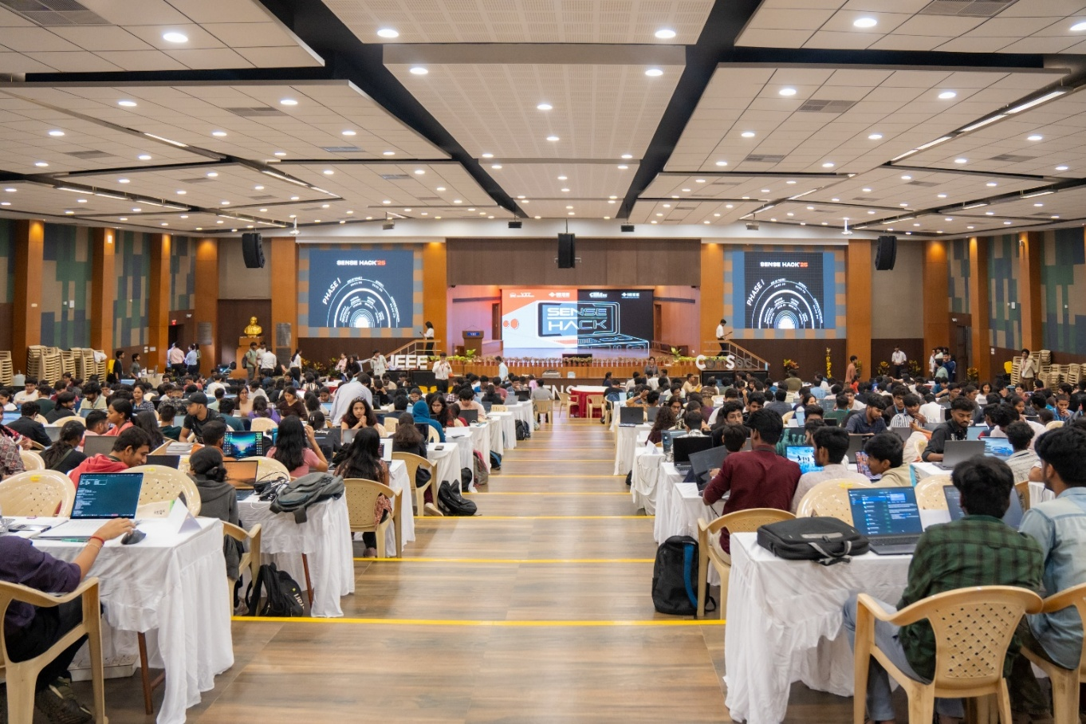
Hacking officially kicked off at 9:30 AM, and teams spent the next couple of hours building their initial ideas and interacting with mentors. A short refreshment break took place at 11:00 AM, after which participants continued working until lunch at 1:00 PM. Post-lunch, entry was regulated again, and teams returned to their projects with renewed energy. Another snack break happened at 4:00 PM, followed by preparation for the review round. Mentors settled in, and the first review, an elimination round, began at 5:30 PM, running smoothly with all teams presenting their ideas.
After the review wrapped up around 7:30 PM, the shortlisted teams were announced. The day ended with a quick vote of thanks, and participants and mentors made their way out.
SHORTLISTED TEAM DETAILS
Internal Teams | 27
External Teams | 15
Freshers Teams | 10
PHASE 2
06/12/2025 08:00 PM to 07/12/2025 08:00 AM
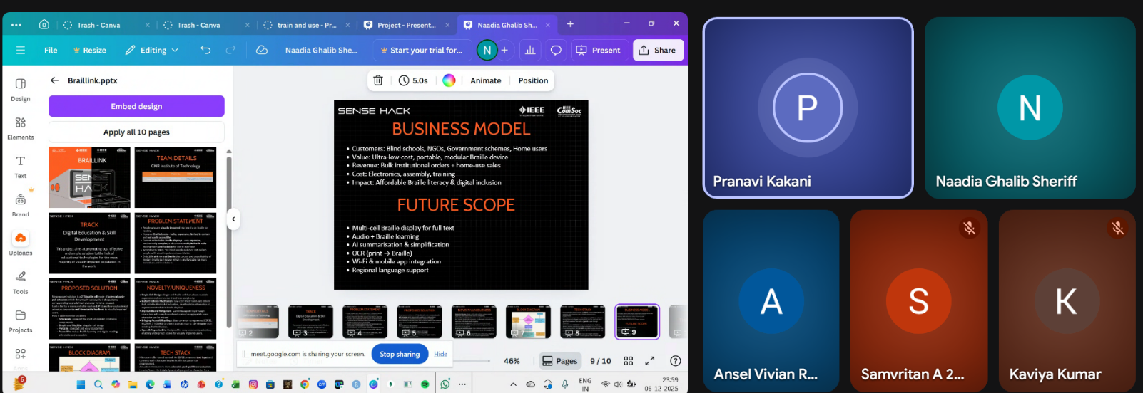
The next phase of the hack took place right here at our own venue, where we also had industry experts from the USA join us online via Google Meet :
- Kapinesh Govindaraju, ASIC Architect (ASIC Engineer), Micron Technology, USA
- Sona Susan Jacob, Sr Engineer Design Engineering, Global Foundries, Texas, USA
- Pranavi, Technical Program Manager, Google, Mountain View, California, USA
- Sruthi Gutha, Design Verification Engineer, Broadcom, USA
The shortlisted teams continued developing their projects and had a progress check with these judges, presenting their work and receiving valuable feedback that helped them refine and move forward effectively.

PHASE 3
07/12/2025 08:00 AM to 06:00 PM
The event began at 8:00 AM with participants checking in smoothly. The teams quickly settled into their preferred tables with their projects. By 9:00 AM, everyone was fully settled and the hackathon continued in full swing with teams interacting with mentors to refine and strengthen their ideas. Our Vice President Dr. Sekar Viswanathan Sir also visited the venue, interacting with participants and checking on the event’s progress. We had a short refreshment break at 11:00 AM, after which the elimination round began at 11:30 AM and continued until 1:00 PM from which the top 10 teams were shortlisted. We were honoured to have our Pro Vice-Chancellor Dr. Partha Sarathi Mallick Sir visit the venue to felicitate our alumni and interact with the teams. This was followed by an insightful talk from Dr. Malay Kumar Nema and Rishiraj Singh Chhabra, motivating the participants further. After announcing the finalists, we moved to the lunch break until 2:00 PM.
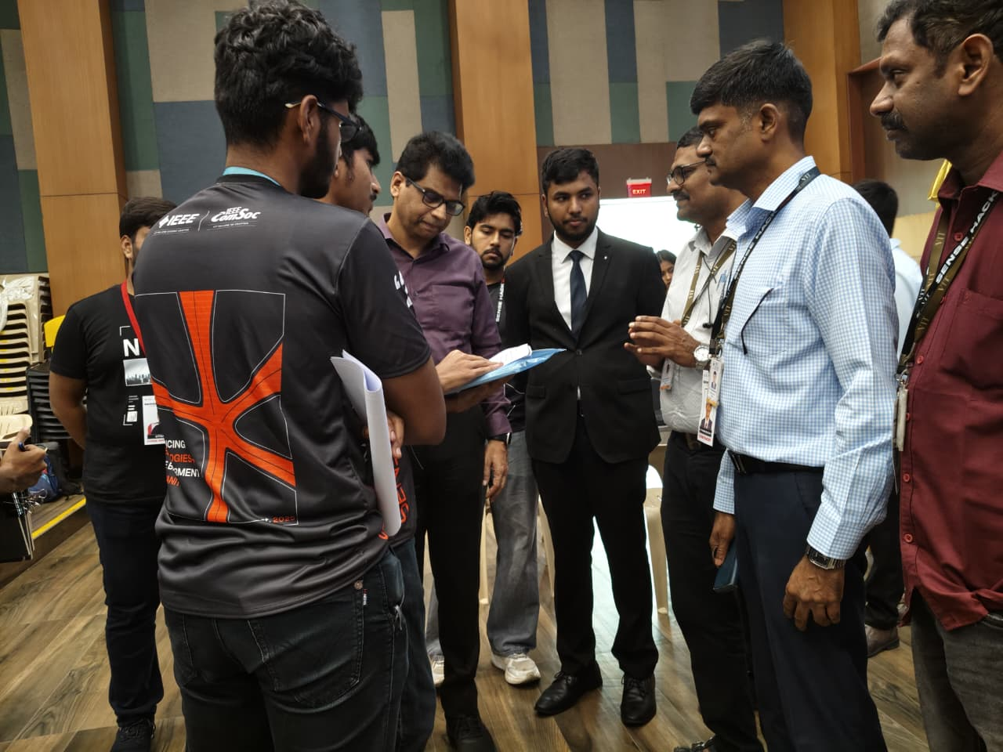 | 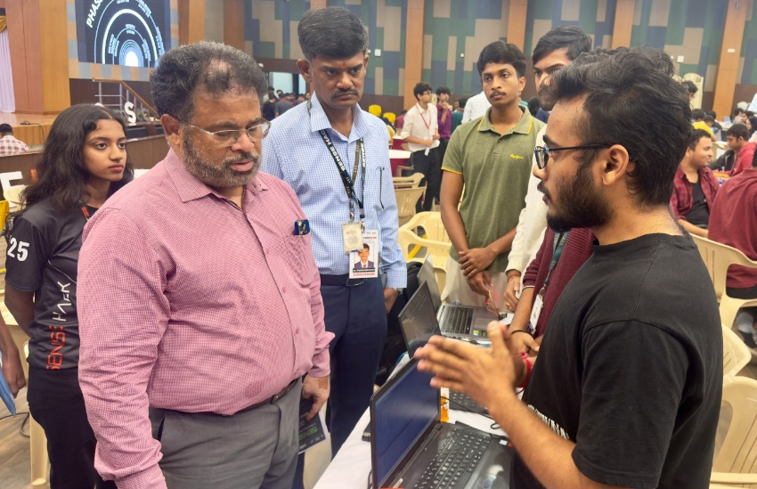
From 2:00 PM, the final stretch of the hackathon began. All the teams were engrossed in preparing their final pitches and completing their projects. A second refreshment break at 4:00 PM helped everyone recharge before the final evaluation round started at 4:30 PM, where each team presented their solutions followed by a Q&A session.

PHASE 4
07/12/2025 06:00 PM to 08:00 PM
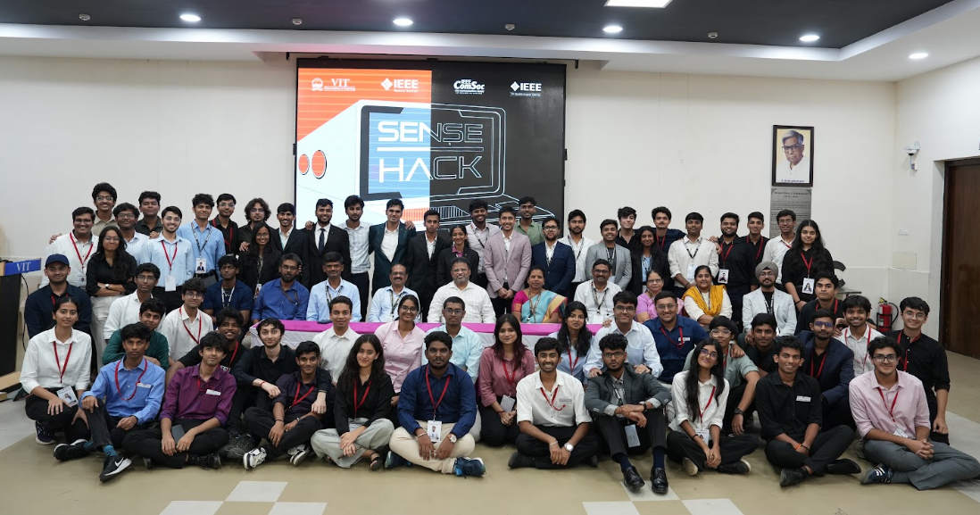
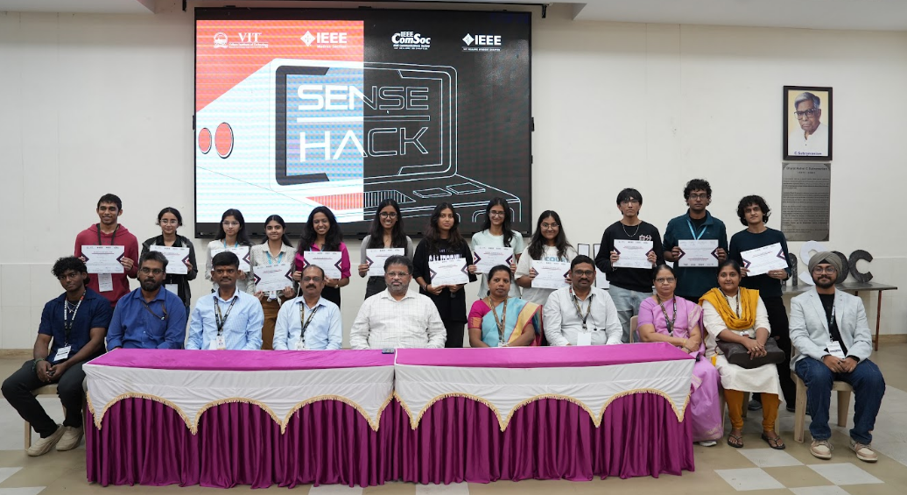
The Valedictory Ceremony took place from 6:00 PM to 8:00 PM, graced by our Pro-Vice Chancellor Dr. Partha Sarathi Mallick sir, Director of Students Welfare C.D. Naiju sir, and Dean of the School of Electronics Engineering Dr. Jasmine ma’am. The ceremony began with the welcome address, followed by the event overview and statistics presented by our faculty coordinators Dr. Arunachalam V and Dr. Thanikaiselvan V.
Winners were then announced, and prizes were distributed. Group photos were taken, and the event concluded with the vote of thanks following which everyone dispersed.

WINNER DETAILS
1st Prize - Team Braillink
ANSEL VIVIAN REGO | CMR Institute of Technology
NAADIA GHALIB SHERIFF | Christ (Deemed to Be) University
2nd Prize - Team Hack Gang
ANUSHKA GATTANI | 24BCE2283 | Vellore Institute of Technology, Vellore
VEDIKA AGARWAL | 24BCE2601 | Vellore Institute of Technology, Vellore
PRISHA RAWAT | 24BCE2545 | Vellore Institute of Technology, Vellore
NAAYSHA JAIN | 24BCE2572 | Vellore Institute of Technology, Vellore
3rd Prize - Team git blame --my-teammates
DIVYAM AGRAWAL | 24BIT0423 | Vellore Institute of Technology, Vellore
KRISHANG ZINZUWADIA | 24BCE2239 | Vellore Institute of Technology, Vellore
NAKUL SINHA | 24BCI0089 | Vellore Institute of Technology, Vellore
Best Freshers Team Award - Team Time Pass
SUGANDHA GUPTA | 25BEC0343 | Vellore Institute of Technology, Vellore
MANISHKA SINGH | 25BCE0982 | Vellore Institute of Technology, Vellore
AVANI VASISTA | 25BCE0941 | Vellore Institute of Technology, Vellore
SHRUTI CHAUDHARY | 25BCE2918 | Vellore Institute of Technology, Vellore

